# HUNGRY BITES

A

Dissertation Of

Submitted in Partial Fulfilment for the requirement for the Award of Degree of Bachelor of Engineering/Technology

In

Computer Science & Engineering

**Submitted To**



**RAJIV GANDHI PROUDYOGIKI VISHWAVIDYALAYA BHOPAL (M.P)**

Submitted By

**Abhisek Mishra 0177CS191007**

**Shivam Vishwakarma 0177CS191158**

## Ritik Srivastava 0177CS191144

**Gunjan Ku. Karn 0177CS191075**

Under Supervision of

## Dr. Anita Soni

**Dr. Nikhat Raza Khan Dr. Anuprita Mishra**

(HOD) (Principal)



**DEPARTMENT OF COMPUTER SCIENCE & ENGINEERING IESCOLLEGE OF TECHNOLOGY, BHOPAL (M.P)**

**SESSION 2022-23**



## CERTIFICATE

This is to certify that the work embodies in this Major Project entitled “**HUNGRY BITES**“ being submitted by "Abhisek Mishra" (0177CS191007) ," Shivam Vishwakarma " (0177CS191158) , " Ritik Srivastava " (0177CS191144) ,"Gunjan Ku. Karn" (0177CS191075) for partial fulfillment of the requirement for the award of “Bachelor of Engineering/Technology in Computer Science & Engineering” to “Rajiv Gandhi Proudyogiki Vishwavidyalaya, Bhopal (M.P)” during the academic year 2022 is a record of bonafide piece of work, carried out by him under my supervision and guidance in IES COLLEGE OF TECHNOLOGY, BHOPAL(M.P).

**Guide HOD Forwarded by**

|  |  |  |
| --- | --- | --- |
| Dr. Anita Soni | Dr. Nikhat Raza | Dr. Anuprita Mishra |
| Asst. professor | Head of department | Principal |
| CSE Department | CSE Department | IES College of Technology |



## APPROVAL CERTIFICATE

The Major Project entitled “**HUNGRY BITES**” being submitted "Abhisek Mishra"(0177CS191007)

," Shivam Vishwakarma " (0177CS191158) , " Ritik Srivastava " (0177CS191144) ,"Gunjan Ku. Karn" (0177CS191075) has been examined by us and is here by approved for the award of degree “Bachelor of Engineering/Technology in Computer Science & Engineering”, for which it has been submitted. It is understood that by this approval the undersigned do not necessarily endorse or approve any statement made, opinion expressed or conclusion drawn therein, but approve the dissertation only for the purpose for which it has been submitted.

**(Internal Examiner) (External Examiner)**

**Date: Date:**

## IES COLLEGE OF TECHNOLOGY, BHOPAL (M.P.)

**Department of Computer Science & Engineering**



## DECLARATION

I hereby declare that the work, which is being presented in Major Project, entitled “**HUNGRY BITES**” partial fulfillment of the requirements for the award of degree of Bachelor of Engineering/Technology in Computer Science & Engineering branch, submitted in the department of **IES College of Technology** is an authentic record of my own work carried under the guidance of “**Dr. Anita Soni” I** have not submitted the matter embodied in report for award of any other degree.

## Abhisek Mishra 0177CS191007

**Shivam Vishwakarma 0177CS191158**

## Ritik Srivastava 0177CS191144

**Gunjan Ku. Karn 0177CS191075**

## ACKNOWLEDGEMENT

We are deeply indebted to our **Principal Dr. Anuprita Mishra,** who modeled us both technically and morally for achieving greater success in life. He showed us different ways to approach a research problem and the need to be persistent to accomplish any goal. We thank him heartily.

We express our deepest gratitude to our **(HOD) Dr Nikhat Raza Khan** for providing us with an environment to complete our project successfully.

We are very grateful to our **Project Guide Dr. Anita Soni** for being instrumental in the completion of our project with his complete guidance.

We also thank all the staff members of our college and technicians for their help in making this project a successful one.

## Abhisek Mishra 0177CS191007

**Shivam Vishwakarma 0177CS191158**

## Ritik Srivastava 0177CS191144

**Gunjan Ku. Kumar 0177CS191075**

## Abstract

The main purpose is to improve the performance of the restaurant by eradicating the daily paperwork. With this system the tasks would be performed in less amount of time and more efficiently. An additional benefit of this software is that during the rush hours the load can be balanced effectively, and restaurants would perform better than usual. In addition to this, human error that occurs when performing tasks manually is also minimized and presence of queues in the system to assign tasks to chefs can reduce congestion in the kitchen. The system would also result in reduction of labor which would result in the reduction of expenses of the restaurant. Feedback module would help the restaurant check for how well they are performing, and monthly/yearly figures can be checked by the billing module to see the trends in sales and profits. These benefits can potentially result in generation of more revenues for the restaurant.

## TABLE OF CONTENTS

**S. No. Description Page No.**

|  |  |  |  |
| --- | --- | --- | --- |
| **1** | **Chapter -1 Introduction** | | **08** |
|  | **1.1 Problem Statement** | | **09** |
|  | **1.2 Solution** | | **09** |
|  | **1.3 Technology Used** | | **09** |
| **2** | **1.4 System Requirement**  **Chapter -2 Diagrams** | | **10** |
|  |  | **2.1 User Case Diagram** | **11** |
|  |  | **2.2 Working diagram** | **11** |
| **3** |  | **Chapter -3 Code** |  |
|  |  | **3.1 Front End** | **12** |
|  |  | **3.2 Back End** | **22** |
|  |  | **3.3 Saving data and transaction** | **22** |
| **4** |  | **Chapter - 4 Screenshots** |  |
|  |  | **4.1 App screenshots** | **25** |
|  |  | **4.2 Database screenshots** | **30** |
| **5** | **`** | **Chapter - 5 Limitations** | **35** |
| **6** |  | **Chapter – 6 Conclusion and Future Scope** | **36** |
| **7** |  | **Chapter – 7 References** | **37** |

## Chapter -1

**Introduction**

Hungry Bites is an Java based Fullstack Online Food Delivery System that aims to digitalize the process of various restaurant operations including ordering, billing kitchen, hall and inventory management.

***What’s new?***

* Unique business idea and can be extended more to restaurants and cloud kitchens.
* Peer-to-peer direct communication.
* Good startup idea.

## Problem Statement:

To design an application for the web so that we can provide a seamless food delivery system, from home in an affordable cost.

## Solution :

A website with a fast database, which will be a platform for common people to interact with different restaurants and cloud kitchen in a very low price.

## Technology Used:

* + - HTML
    - JavaScript
    - Spring Boot
    - CSS
    - Payment Gateway Integration

## Recommended System Requirement for Development (Android Studio 4.0)

**Operating System :** 64-bit Microsoft® Windows® 8/10

**Ram :** 4 GB RAM or more

**Screen resolution :** 1280 x 800 minimum

**Hard disk :** 8 GB of available disk space minimum

**Software :** Visual studio code, Node JS

**CPU Architecture :** x86_64 CPU architecture; 2nd generation Intel Core or newer

## Recommended System Requirement to run the project

**Web Browser :** Recommended Google chrome ,Any web browser

**Ram :** 1 GB RAM or more

**Screen resolution :** Recommended 1280 x 800 , can work on any resolution

**Rom :** 100 MB of available disk space minimum ( Cache size 50 MB)

## Chapter -2

**User case Diagram**

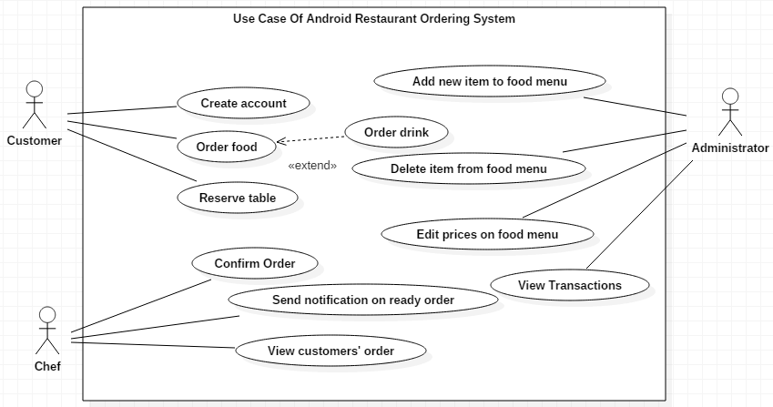

**Work Flow Diagram**

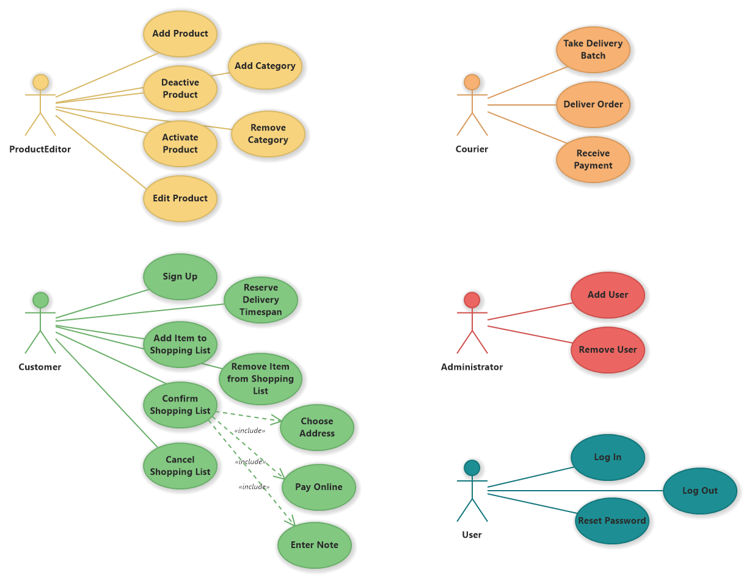

## Chapter -3 Code

* 1. **Front end (Index.html )**

<!DOCTYPE html>

<html lang="en">

<head>

<meta charset="UTF-8">

<meta http-equiv="X-UA-Compatible" content="IE=edge">

<meta name="viewport" content="width=device-width, initial-scale=1.0">

<title>Hungry Bites</title>

<meta name="viewport" content="width=device-width, initial-scale=1">

<!-- css link -->

<link rel="stylesheet" type="text/css" href="css/style.css">

<!-- bootstrap css -->

<link href="https://cdn.jsdelivr.net/npm/bootstrap@5.0.2/dist/css/bootstrap.min.css" rel="stylesheet" integrity="sha384-EVSTQN3/azprG1Anm3QDgpJLIm9Nao0Yz1ztcQTwFspd3yD65VohhpuuCOmLASjC" crossorigin="anonymous">

</head>

<body>

<nav class="navbar navbar-expand-lg navbar-light bg-white">

<div class="container-fluid">

<a class="navbar-brand text-capitalize" href="#">Hungry Bites</a>

<button class="navbar-toggler" type="button" data-bs-toggle="collapse" data-bs-target="#navbarSupportedContent" aria-controls="navbarSupportedContent" aria-expanded="false" aria-label="Toggle navigation">

<span class="navbar-toggler-icon"></span>

</button>

<div class="collapse navbar-collapse" id="navbarSupportedContent">

<ul class="navbar-nav ml-auto mb-2 mb-lg-0">

<li class="nav-item">

<a class="nav-link active" aria-current="page" href="index.html">Home</a>

</li>

<li class="nav-item">

<a class="nav-link text-capitalize" href="index.html#aboutus">About us</a>

</li>

<li class="nav-item dropdown">

<a class="nav-link dropdown-toggle" href="" id="navbarDropdown" role="button" data-bs-toggle="dropdown" aria-expanded="false"> Services </a>

<ul class="dropdown-menu" aria-labelledby="navbarDropdown">

<li>

<a class="dropdown-item" href="index.html#ourservices">Our Services</a>

</li>

<li>

<a class="dropdown-item" href="index.html#onlineservices">Order Online Service

</a>

</li>

</ul>

</li>

<li class="nav-item">

<a class="nav-link text-capitalize" href="index.html#gallery">Gallery</a>

</li>

<li class="nav-item">

<a class="nav-link text-capitalize" href="index.html#contact">Contact us</a>

</li>

</ul>

</div>

</div>

</nav>

<header>

<div id="carouselExampleCaptions" class="carousel slide" data-bs-ride="carousel">

<div class="carousel-indicators">

<button type="button" data-bs-target="#carouselExampleCaptions" data-bs-slide-to="0" class="active" aria-current="true" aria-label="Slide 1"></button>

<button type="button" data-bs-target="#carouselExampleCaptions" data-bs-slide-to="1" aria-label="Slide 2"></button>

<button type="button" data-bs-target="#carouselExampleCaptions" data-bs-slide-to="2" aria-label="Slide 3"></button>

<button type="button" data-bs-target="#carouselExampleCaptions" data-bs-slide-to="3" aria-label="Slide 4"></button>

<button type="button" data-bs-target="#carouselExampleCaptions" data-bs-slide-to="4" aria-label="Slide 5"></button>

</div>

<div class="carousel-inner">

<div class="carousel-item active">

<img src="images/download1.jpg" class="d-block w-100 z" alt="images/images1.jpg">

<div class="carousel-caption d-md-block">

<h5>Hungry Bites</h5>

<p>Some of the Best views of our Hungry Bites.</p>

</div>

</div>

<div class="carousel-item">

<img src="images/images99.jpg" class="d-block w-100 z" alt="images/recipe-1.jpeg">

<div class="carousel-caption d-md-block">

<h5>Hungry Bites</h5>

<p>Some of the Best views of our Hungry Bites.</p>

</div>

</div>

<div class="carousel-item">

<img src="images/images78.jpg" class="d-block w-100 z" alt="images/recipe-1.jpeg">

<div class="carousel-caption d-md-block">

<h5>Hungry Bites</h5>

<p>Some of the Best views of our Hungry Bites.</p>

</div>

</div>

<div class="carousel-item">

<img src="images/images9.jpg" class="d-block w-100 z" alt="images/recipe-1.jpeg">

<div class="carousel-caption d-md-block">

<h5>Hungry Bites</h5>

<p>Some of the Best views of our Hungry Bites.</p>

</div>

</div>

<div class="carousel-item">

<img src="images/images6.jpg" class="d-block w-100 z" alt="images/recipe-1.jpeg">

<div class="carousel-caption d-md-block">

<h5>Hungry Bites</h5>

<p>Some of the Best views of our Hungry Bites.</p>

</div>

</div>

</div>

<button class="carousel-control-prev" type="button" data-bs-target="#carouselExampleCaptions" data-bs-slide="prev">

<span class="carousel-control-prev-icon" aria-hidden="true"></span>

<span class="visually-hidden">Previous</span>

</button>

<button class="carousel-control-next" type="button" data-bs-target="#carouselExampleCaptions" data-bs-slide="next">

<span class="carousel-control-next-icon" aria-hidden="true"></span>

<span class="visually-hidden">Next</span>

</button>

</div>

</header>

<!-- ABOUT US SECTION START -->

<section class="main heading my-5 bg-light py-5" id="aboutus">

<div class="text-center">

<h1 class=" display-4 ap">About Us</h1>

<hr class="w-25 mx-auto">

<!-- m mtb margin -->

<!-- y mtb uppar aur niche -->

<!-- x mtb left and right -->

</div>

<!-- <div class="container-fluid bg-primary"> -->

<div class="container ">

<div class="row my-5">

<div class="col-lg-6 col-md-6 col-12 col-xxl-6 ">

<figure>

<img src="images/images44.jpeg" alt="about image" class="img-fluid about_img">

</figure>

</div>

<div class="col-lg-6 col-md-6 col-12 col-xxl-6 d-flex justify-content-center align-items-start flex-column">

<!-- lg:large -->

<h1>Our Story</h1>

<p>The Hungry Bites - The DR - reinvents the neighborhood eatery, combining timeless inspiration from classic Indian with inventive and playful modern flair. With influences ranging dinner to the elegant railway dining cars of days past, you'll find a nostalgic collection of comforts, classics and curiosities with a modern twist.We provide every type of food like Indian, American, Chinese, Italian etc.Located in the heart of the people, the Hungry Bites is inspired by the exciting and traditional flavors of Indian Species.

</p>

<a class="btn btn-primary" href="index.html">Visit Hungry Bites</a>

<!-- tooltip -->

</div>

</div>

</div>

</section>

<!-- our services sec start -->

<!-- popper.js first, then bootstrap js -->

<section class="main_heading my-5 bg-light pt-5" id="ourservices">

<div class="text-center">

<h1 class="display-4">Our Services</h1>

<hr class="w-25 mx-auto" />

</div>

<div class="container services">

<div class="row my-5">

<div class="col-md-4 col-10 col-xxl-4 mx-auto">

<div class="card mx-2 mb-2" style="max-width: 540px;">

<!-- mb : margin bottom -->

<div class="row">

<div class="col-md-4">

<img src="images/buffet.jpg" alt="services images" class="img-fluid">

</div>

<div class="col-md-8">

<div class="card-body">

<h5 class="card-title"> Buffet service</h5>

<p class="card-text">In a buffet service, guests can choose their food from a wider selection made available on the buffet line.</p>

<p class="card-text">

<small class="text-muted">Waiters focus only on serving a few dishes and clearing tables.</small>

</p>

</div>

</div>

</div>

</div>

</div>

<div class="col-md-4 col-10 col-xxl-4 mx-auto">

<div class="card mx-2 mb-2" style="max-width: 540px;">

<!-- mb : margin bottom -->

<div class="row">

<div class="col-md-4">

<img src="images/waiter.png" alt="services images" class="img-fluid">

</div>

<div class="col-md-8">

<div class="card-body">

<h5 class="card-title">Waiter service</h5>

<p class="card-text">More commonly known as sit-down service, a waiter takes care of everything from taking orders to serving food and payment.</p>

<p class="card-text">

<small class="text-muted">Service is more personalized as diners.</small>

</p>

</div>

</div>

</div>

</div>

</div>

<div class="col-md-4 col-10 col-xxl-4 mx-auto">

<div class="card mx-2 mb-2" style="max-width: 540px;">

<!-- mb : margin bottom -->

<div class="row">

<div class="col-md-4">

<img src="images/online.jpg" alt="services images" class="img-fluid">

</div>

<div class="col-md-8">

<div class="card-body">

<h5 class="card-title">Online Ordering Service</h5>

<p class="card-text">Online ordering systems allow restaurants and food businesses to serve their customers through a mobile app or a website.</p>

<p class="card-text">

<small class="text-muted">Makes the ordering process easier. </small>

</p>

</div>

</div>

</div>

</div>

</div>

<div class="col-xxl-12 text-center my-5">

<!-- <button type="button" class="btn btn-outline-info" data-toggle="tooltip" data-placement="right" title="Check More">Check more</button> -->

</div>

</div>

</div>

<!--

<div class="col-md-4 col-10 col-xxl-4 mx-auto"><div class="col-md-4 col-10 col-xxl-4 mx-auto"></div> -->

</section>

<!-- gallery section start here -->

<section class="main heading my-5 bg-body -p py-5" id="gallery">

<div class="text-center">

<h1 class=display-4>Gallery</h1>

<hr class="w-25 mx-auto">

<!-- m mtb margin -->

<!-- y mtb uppar aur niche -->

<!-- x mtb left and right -->

</div>

<div class="container">

<div class="row gy-2 gx-4 my-5">

<div class=" col-md-4 col-10 col-xxl-4 mx-auto">

<figure>

<img src="images/food1.jpg" alt="gallery" class="img-fluid a">

</figure>

</div>

<div class="col-md-4 col-10 col-xxl-4 mx-auto">

<figure>

<img src="images/food2.jpg" alt="gallery" class="img-fluid a">

</figure>

</div>

<div class="col-md-4 col-10 col-xxl-4 mx-auto">

<figure>

<img src="images/food3.jpg" alt="gallery" class="img-fluid a">

</figure>

</div>

<div class="col-md-4 col-10 col-xxl-4 mx-auto">

<figure>

<img src="images/food44.jpg" alt="gallery" class="img-fluid a">

</figure>

</div>

<div class="col-md-4 col-10 col-xxl-4 mx-auto">

<figure>

<img src="images/food5.jpg" alt="gallery" class="img-fluid a">

</figure>

</div>

<div class="col-md-4 col-10 col-xxl-4 mx-auto">

<figure>

<img src="images/food15.jpg" alt="gallery" class="img-fluid a">

</figure>

</div>

<div class="col-md-4 col-10 col-xxl-4 mx-auto">

<figure>

<img src="images/food13.jpg" alt="gallery" class="img-fluid a">

</figure>

</div>

<div class="col-md-4 col-10 col-xxl-4 mx-auto">

<figure>

<img src="images/recipe-3.jpeg" alt="gallery" class="img-fluid a">

</figure>

</div>

<div class="col-md-4 col-10 col-xxl-4 mx-auto">

<figure>

<img src="images/food16.jpg" alt="gallery" class="img-fluid z">

</figure>

</div>

</div>

</div>

</div>

</section>

<!--

offers -->

<section class="main heading my-5 py-4 offer_style" id="onlineservices">

<div class="container-fluid">

<div class="row">

<div class="col-xxl-12 col-12 py-15 text-center">

<h1 class="text-white">Order Online Service</h1>

<p>Hungry Bites is the best Restaurant in the world , here you can order the food , you will get a lot of services, you will enjoy Hungry Bites via it's all the services .</p>

<button type="button" class="btn btn-outline-light" data-placement="right" title="Order Online" data-bs-toggle="modal" data-bs-target="#exampleModal">

<!-- Launch demo modal -->

<svg xmlns="http://www.w3.org/2000/svg" width="16" height="16" fill="currentColor" class="bi bi-arrow-right-circle" viewBox="0 0 16 16">

<path fill-rule="evenodd" d="M1 8a7 7 0 1 0 14 0A7 7 0 0 0 1 8zm15 0A8 8 0 1 1 0 8a8 8 0 0 1 16 0zM4.5 7.5a.5.5 0 0 0 0 1h5.793l-2.147 2.146a.5.5 0 0 0 .708.708l3-3a.5.5 0 0 0 0-.708l-3-3a.5.5 0 1 0-.708.708L10.293 7.5H4.5z" />

</svg> Check more

</button>

</div>

</div>

<!-- m mtb margin -->

<!-- y mtb uppar aur niche -->

<!-- x mtb left and right -->

</section>

<!-- modal -->

<!-- Button trigger modal

<button type="button" class="btn btn-primary" data-bs-toggle="modal" data-bs-target="#exampleModal">

Launch demo modal

</button> -->

<!-- Modal -->

<div class="modal fade" id="exampleModal" tabindex="-1" aria-labelledby="exampleModalLabel" aria-hidden="true" >

<div class="modal-dialog modal-dialog-centered" >

<div class=" modal-content">

<div class="modal-header">

<h5 class="modal-title" id="exampleModalLabel" >Online Food Service</h5>

<button type="button" class="btn-close" data-bs-dismiss="modal" aria-label="Close"></button>

</div>

<div class="modal-body">

<h3>I hope u will enjoy Online Food Service</h3>

</div>

<div class="modal-footer">

<button type="button" class="btn btn-secondary" data-bs-dismiss="modal">Close</button>

<a href="https://www.zomato.com/">

<button type="button" class="btn btn-primary">Check Now</button>

</a>

</div>

</div>

</div>

</div>

<!-- contact us -->

<section class="main heading my-5 bg-light py-5" id="contact">

<div class="text-center">

<h1 class=display-4>Contact us</h1>

<!-- center mai lanne ke liye mx-auto likte hai -->

<hr class="w-25 mx-auto" />

<!-- m mtb margin -->

<!-- y mtb uppar aur niche -->

<!-- x mtb left and right -->

</div>

<div class="container" >

<div class="row">

<div class="col-xxl-8 col-10 col-md-8 mx-auto">

<form>

<div class="mb-3">

<label for="exampleInputPassword1" class="form-label">Name</label>

<input type="text" class="form-control" id="exampleInputPassword1" placeholder="Enter your name">

</div>

<div class="mb-3">

<label for="exampleInputEmail1" class="form-label">Email address</label>

<input type="email" class="form-control" id="exampleInputEmail1" aria-describedby="emailHelp">

<div id="emailHelp" class="form-text">We'll never share your email with anyone else.</div>

</div>

<div class="mb-3">

<label for="exampleInputPassword1" class="form-label">Password</label>

<input type="text" class="form-control" id="exampleInputPassword1">

</div>

<div class="mb-3">

<label class="pr-4">Gender &nbsp &nbsp </label>

<div class="form-check form-check-inline">

<input class="form-check-input" type="radio" name="inlineRadioOptions" id="inlineRadio1" value="option1">

<label class="form-check-label" for="inlineRadio1"> Female</label>

</div>

<div class="form-check form-check-inline">

<input class="form-check-input" type="radio" name="inlineRadioOptions" id="inlineRadio2" value="option2">

<label class="form-check-label" for="inlineRadio2">Male</label>

</div>

</div>

<div class="mb-3">

<label for="exampleDataList" class="form-label">City</label>

<input class="form-control" list="datalistOptions" id="exampleDataList" placeholder="">

<datalist id="datalistOptions">

</datalist>

</div>

<div class="mb-3">

<label for="exampleFormControlTextarea1" class="form-label">Example text area</label>

<textarea class="form-control" id="exampleFormControlTextarea1" rows="3"></textarea>

</div>

<div class="mb-3 form-check">

<input type="checkbox" class="form-check-input" id="exampleCheck1">

<label class="form-check-label" for="exampleCheck1">Check me out</label>

</div>

<button type="submit" class="btn btn-primary">Submit</button>

</div>

</div>

</div>

</form>

</section>

<footer class="bg-secondary text-center text-white">

<p>@copyright Hungry Bites </p>

</footer>

<script src="https://cdn.jsdelivr.net/npm/bootstrap@5.0.2/dist/js/bootstrap.bundle.min.js" integrity="sha384-MrcW6ZMFYlzcLA8Nl+NtUVF0sA7MsXsP1UyJoMp4YLEuNSfAP+JcXn/tWtIaxVXM" crossorigin="anonymous"></script>

<script type="text/javascript">

var tooltipTriggerList = [].slice.call(document.querySelectorAll('[data-bs-toggle="tooltip"]'))

var tooltipList = tooltipTriggerList.map(function(tooltipTriggerEl) {

return new bootstrap.Tooltip(tooltipTriggerEl)

})

</script>

</body>

</html>

## Authentication Code

*Sign up – Email and Password*

try{

createUserWithEmailAndPassword(auth, email, pass)

.then((userCredential) => {

// Signed in

const user = userCredential.user;

alert("Registered Successfully , Please Wait") if(user==="common")

window.location.href = "cdash.html"; else window.location.href="ldash.html";

})

.catch((error) => { document.getElementById("ww").style.display="none"; const errorCode = error.code;

const errorMessage = error.message; alert(errorMessage)

// ..

});

}

catch(e)

{

alert(e); document.getElementById("ww").style.display="none";

}

## Saving user’s data into firebase database

const auth = getAuth(); console.log("2sdfasdf")

const db = getFirestore(app); try{

var add=user/'+email; console.log(add)

const docData = { Name: name, dob: dob, mobile: mobile,

role:e

};

setDoc(doc(db,"users",email), docData);

*Sign in for already registered user*

auth.signInWithEmailAndPassword(email, password)

.addOnCompleteListener(this) { task -> if (task.isSuccessful) {

// Sign in success, update UI with the signed-in user's information Toast.makeText(

baseContext, " !!! Welcome !!!!.", Toast.LENGTH_SHORT

).show()

val user = auth.currentUser updateUI(user)

} else {

// If sign in fails, display a message to the user.

Toast.makeText(

baseContext, "Authentication failed.", Toast.LENGTH_SHORT

).show() updateUI(null)

}

}

***Automatic login if already login previously***

getAuth(app).onAuthStateChanged(function(user) { if (user) {

const db = getFirestore(app);

getDoc(doc(db, "users", user.email)).then(docSnap => { if (docSnap.exists()) {

//.//console.log("Document data:", docSnap.data());

if(docSnap.data().role==="common") window.location.href = "cdash.html"; else{

window.location.href = "ldash.html";

}

}

fun gotoregisterationfun(view: View) {

val intent=Intent(this,StudentRegister::class.java) startActivity(intent)

}

fun forgetfun(view: View) {

val intent=Intent(this,forgetpassword::class.java) startActivity(intent)}

}

## Chapter - 4 Screen shots

**Home Page**

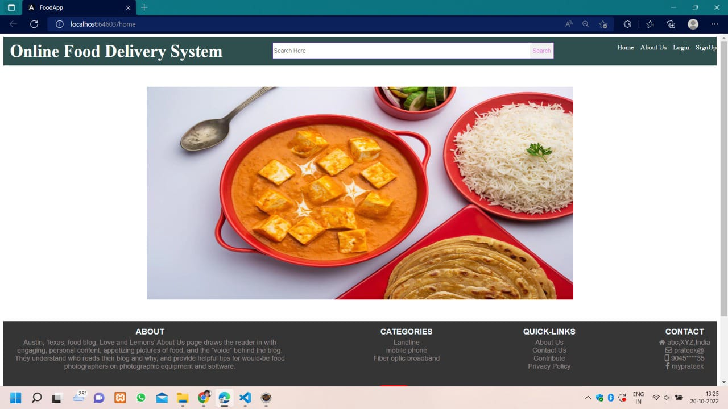

**Login Page**

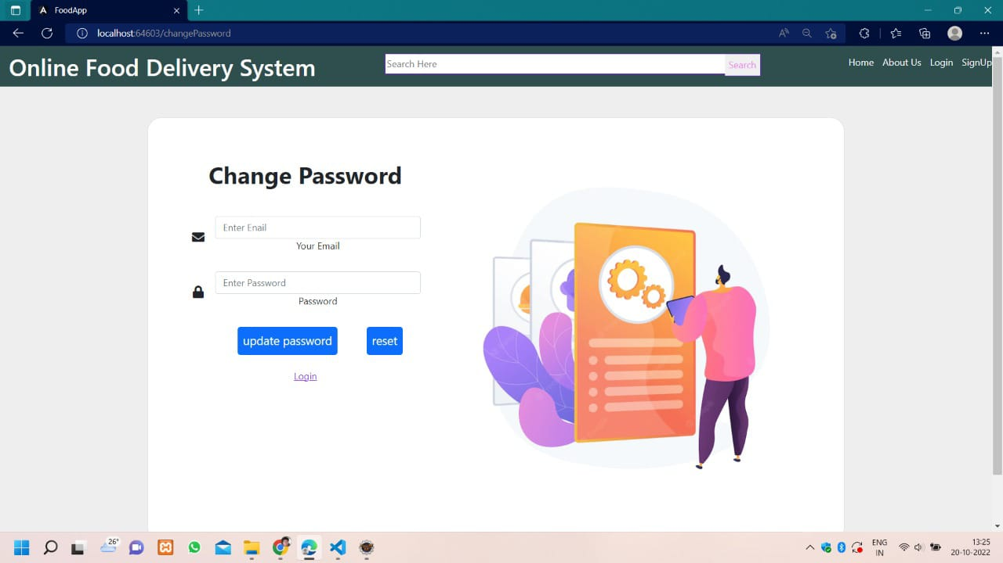

**Payment Page**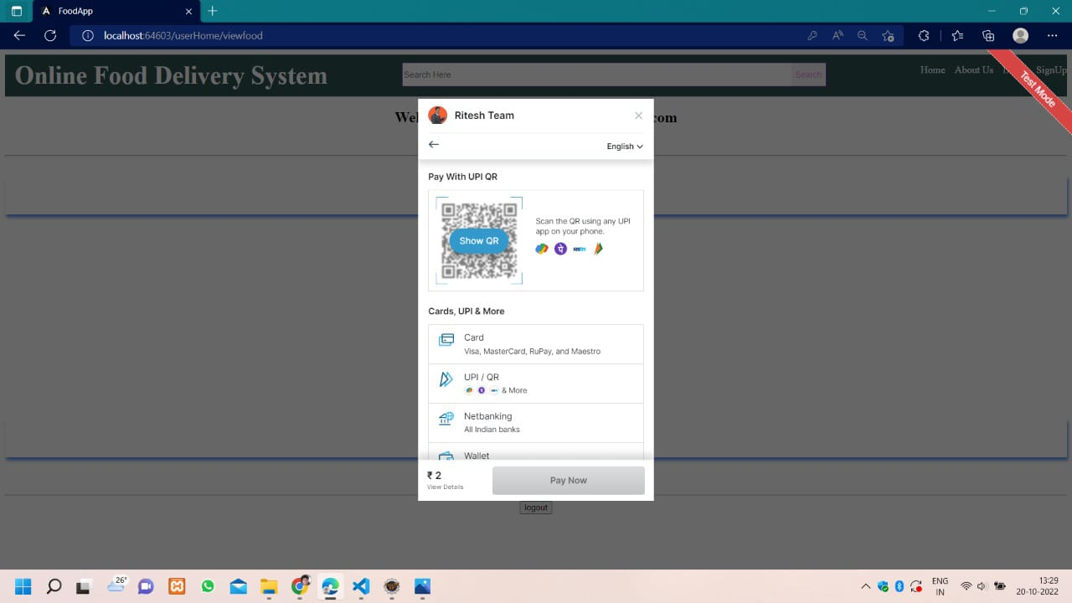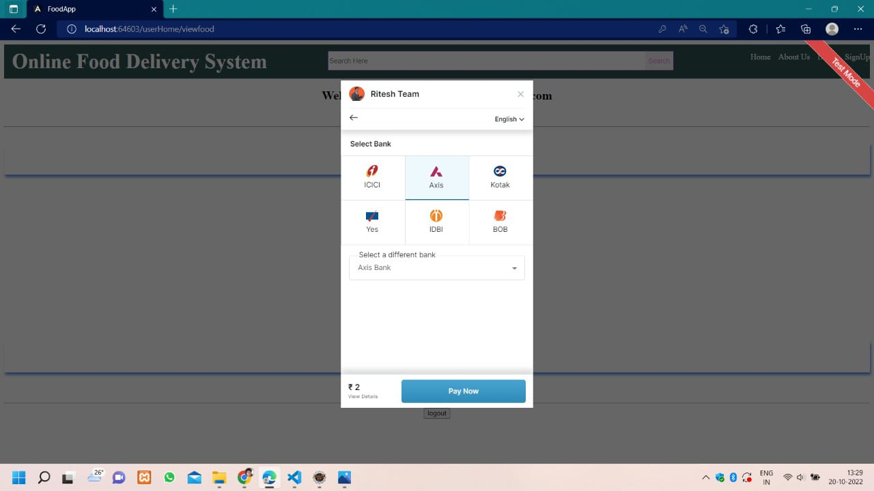

**User Welcome Page**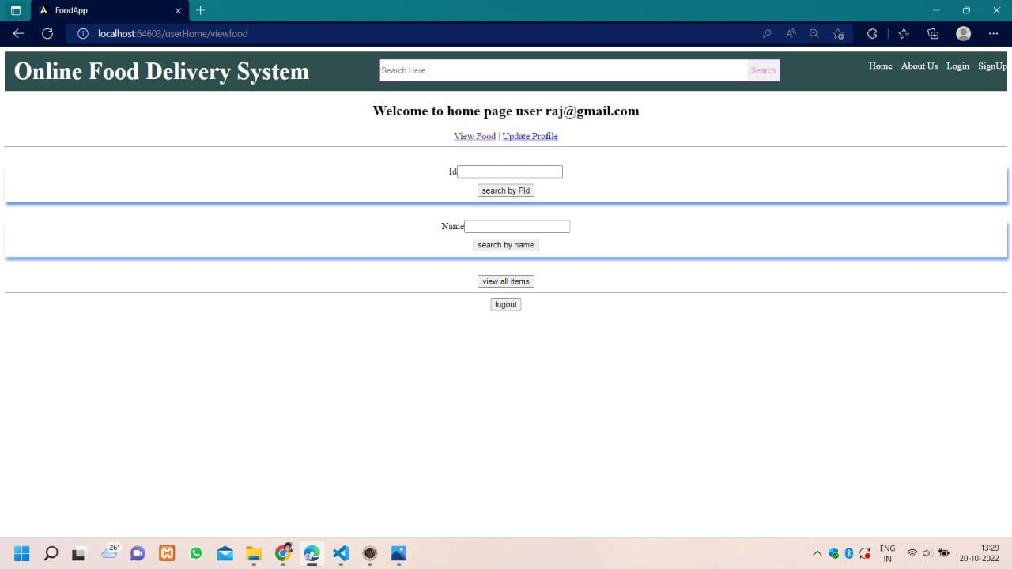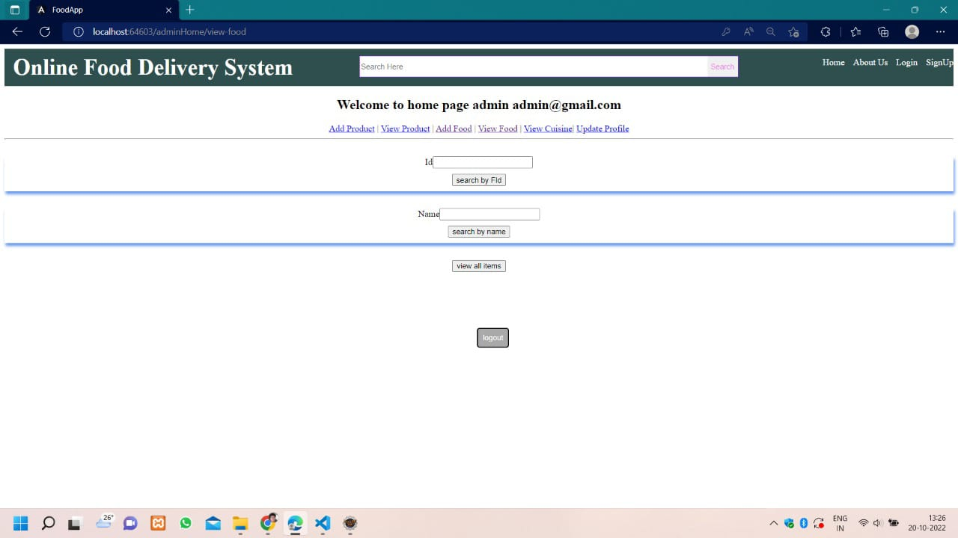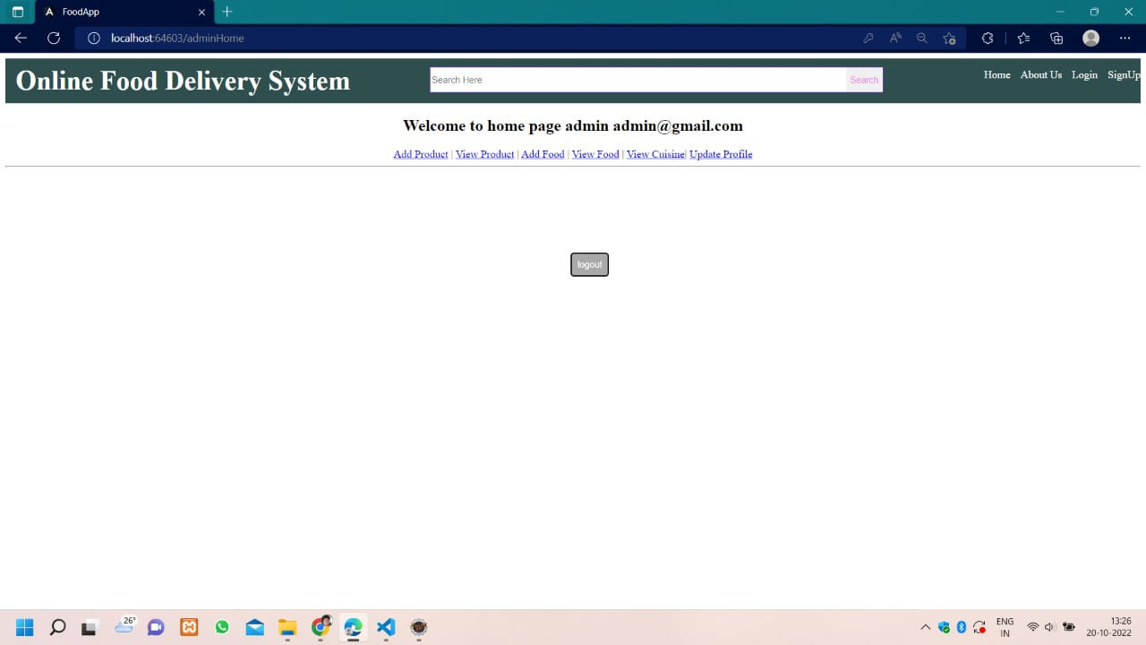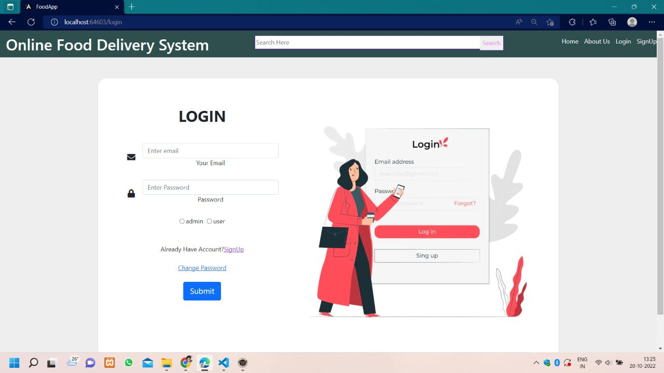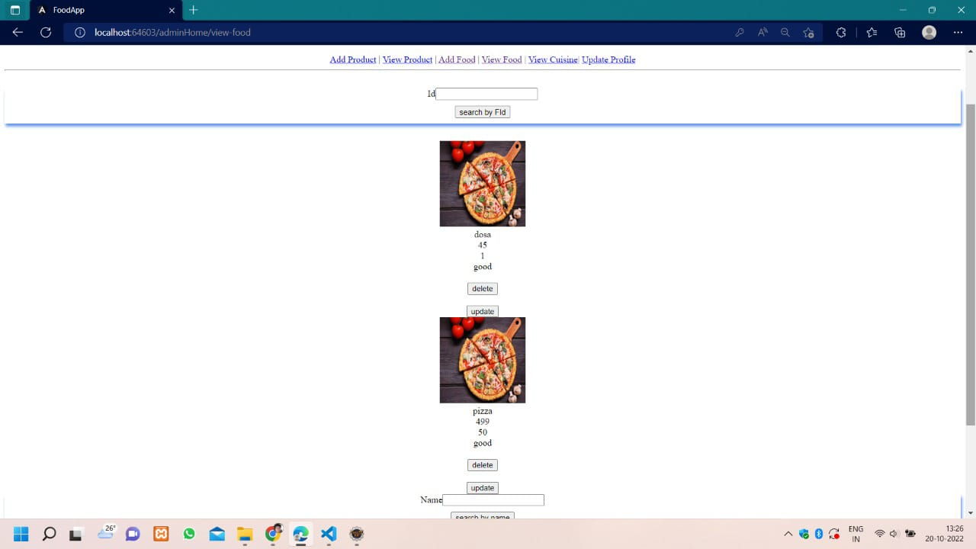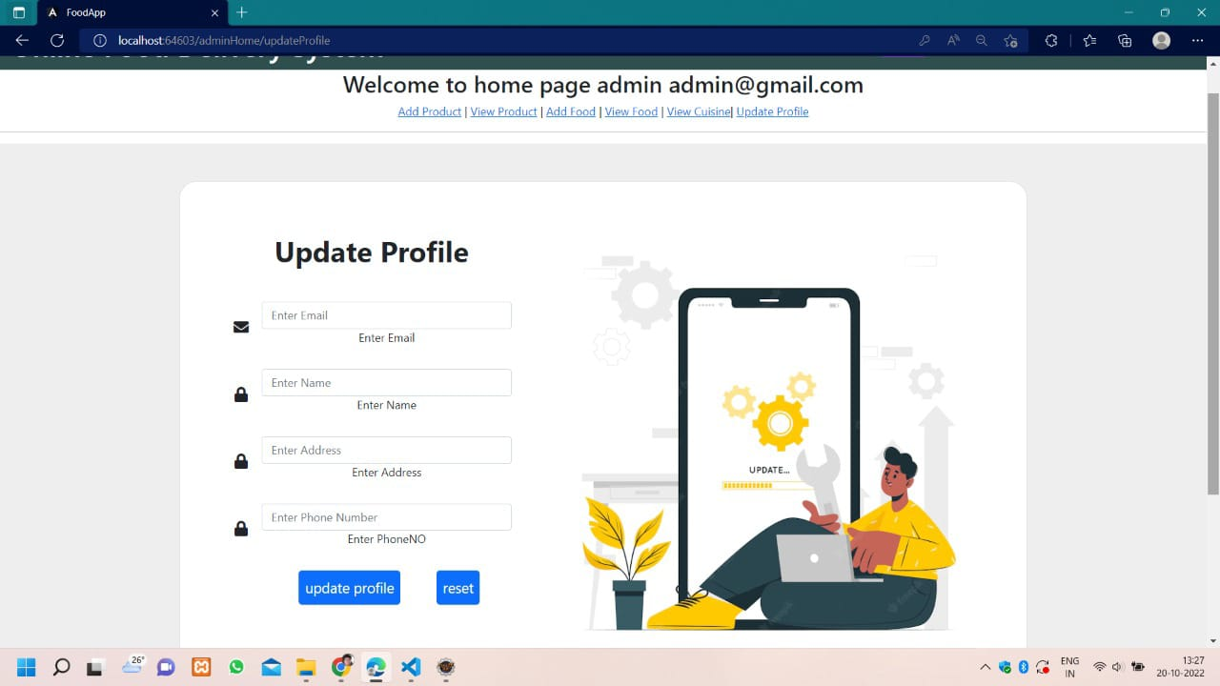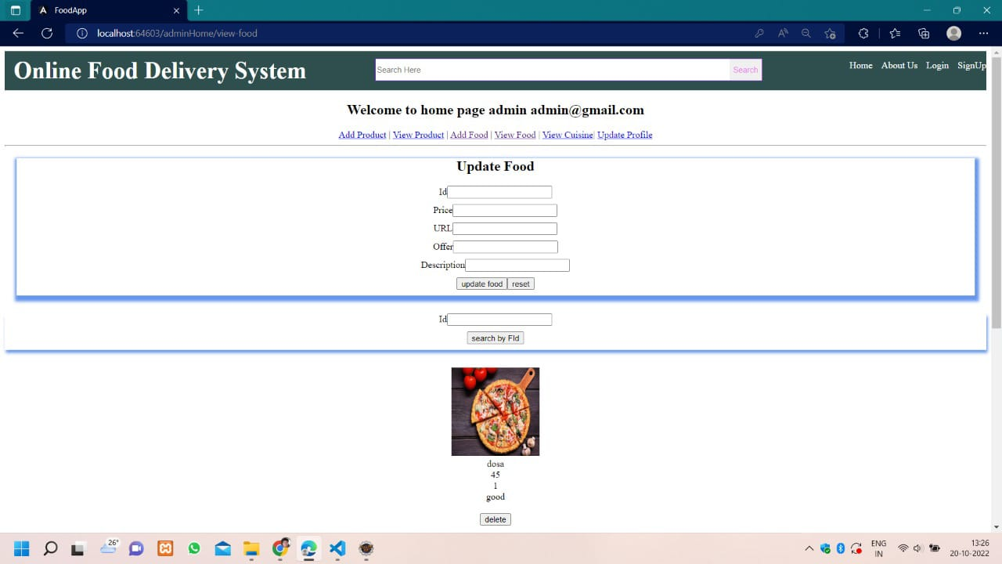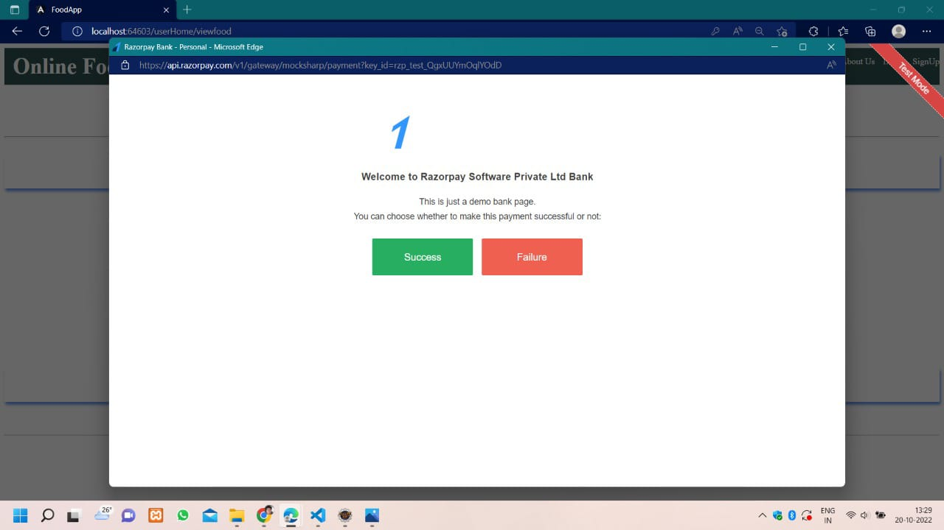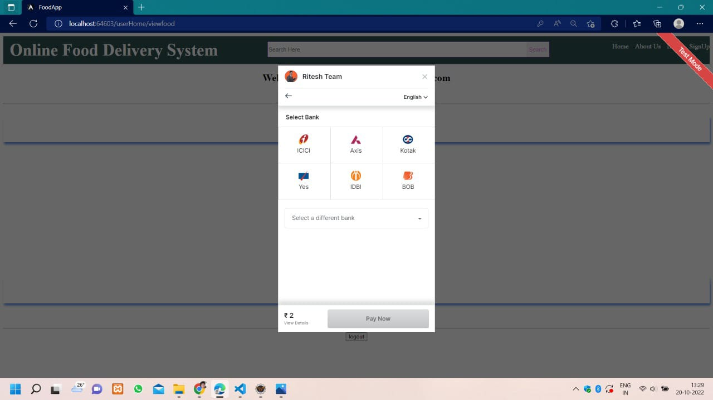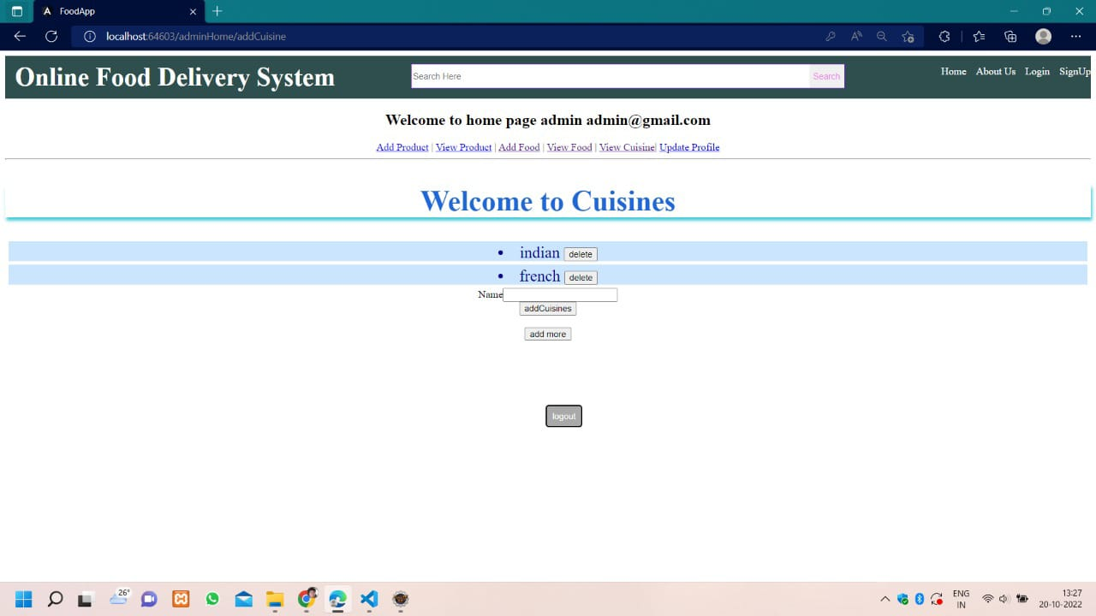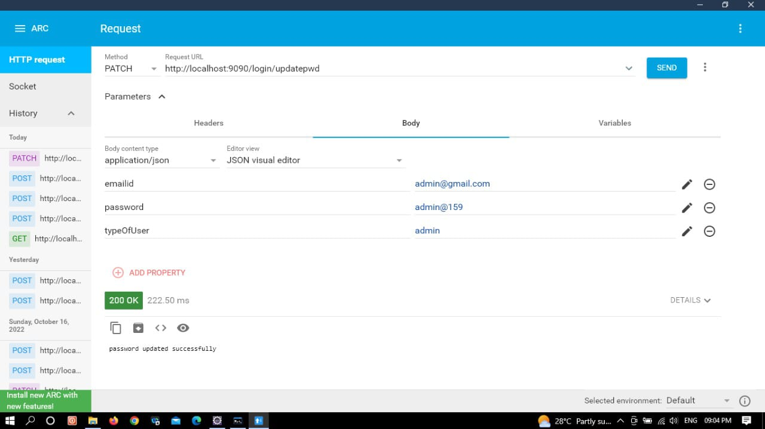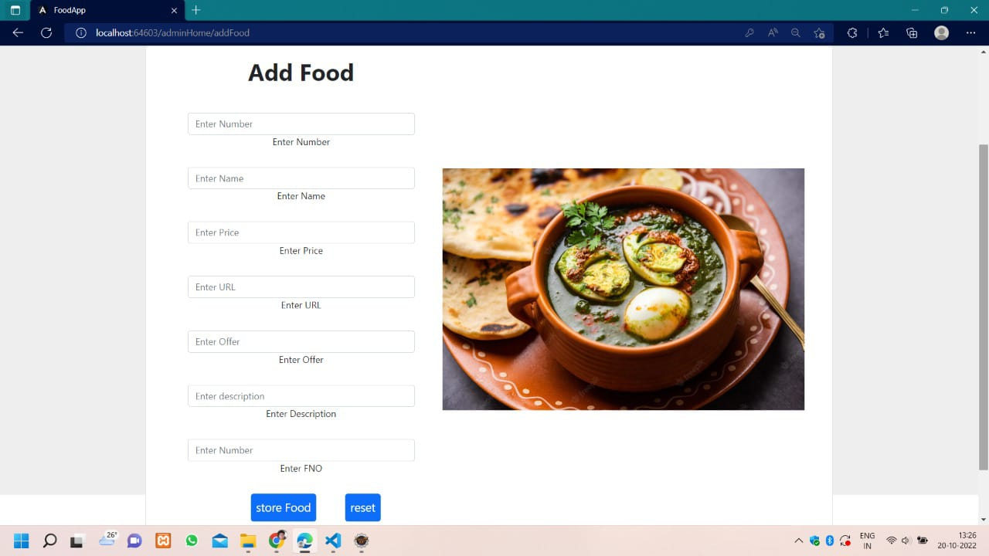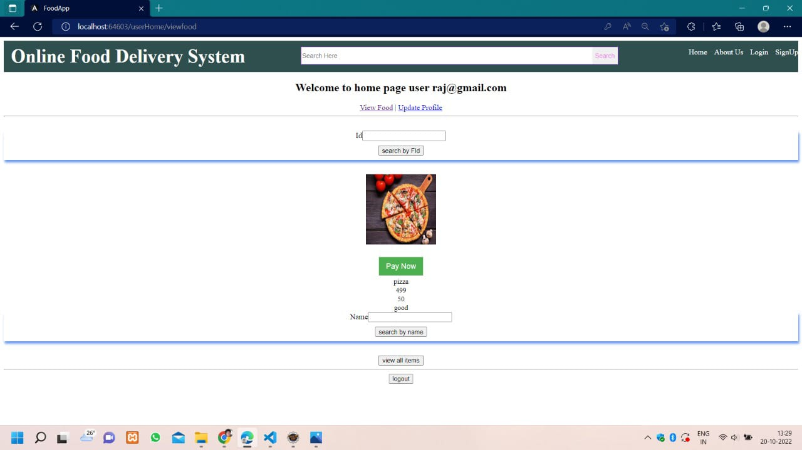

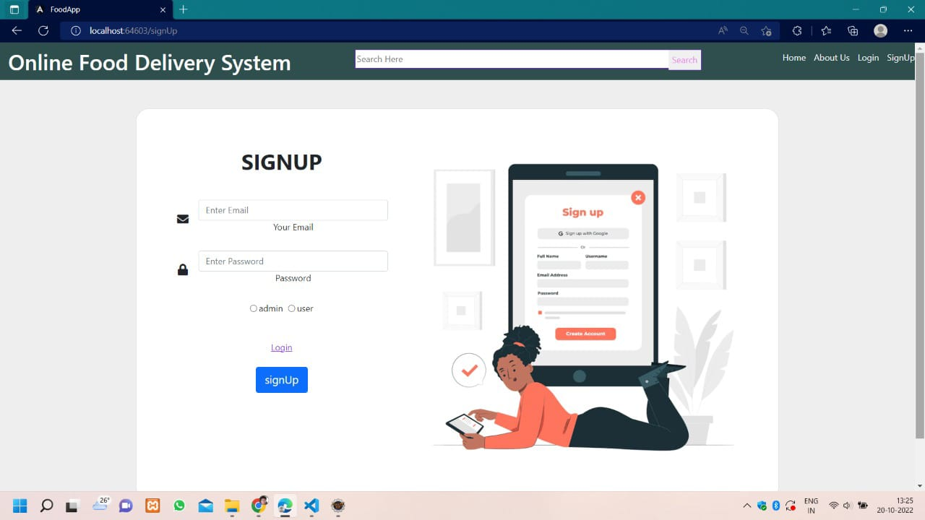

**API Authentication**

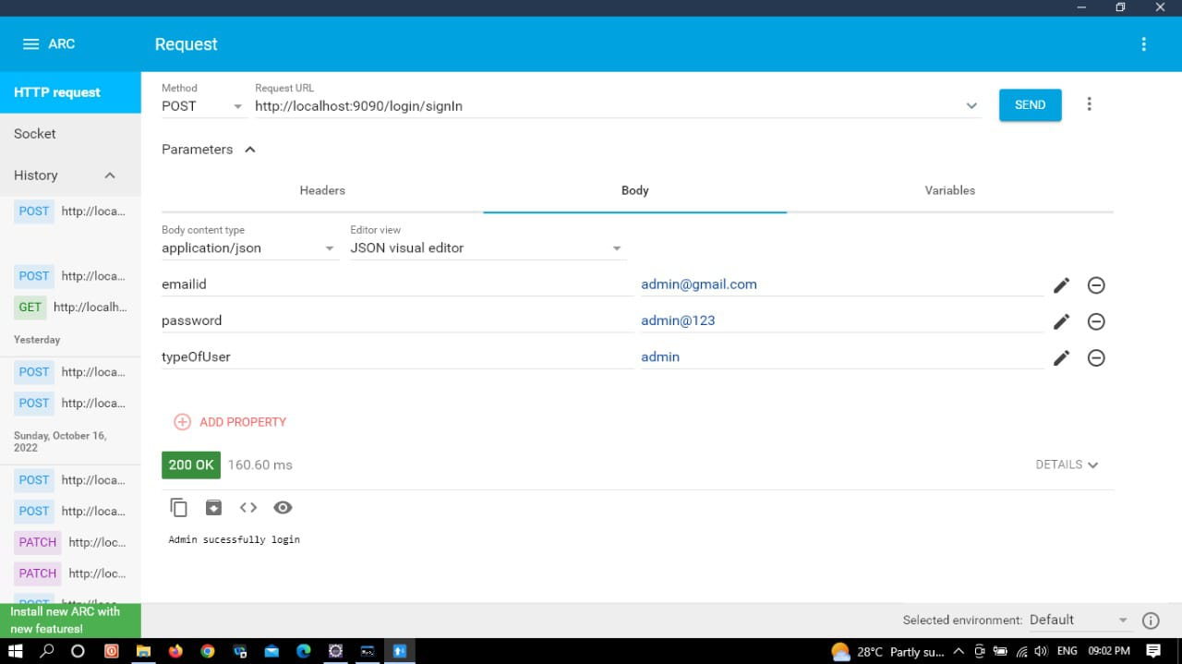

## Chapter – 5

**LIMITATIONS**

* Any common man can register in app with no verification.
* Dependent on user’s interest.
* No complex features.
* No admin user to add/ remove app users of a particular section.

## Chapter – 6

**CONCLUSION & FUTURE SCOPE**

## CONCLUSION

The conclusions of this study suggest that knowledge of specific domain improves the results. This Project has been implemented on web platform. Also, different attributes have been added to the project which will prove to be advantageous to the system. The requirements and specifications have been listed above. This project is implemented using Java and it’s services.

**Future Scope**

* + In app notification can be added, any notification can be sent to user and food provider smartphone.
  + Admin authentication can be added to save only verified users.
  + Different price section can be added for different timings to convert it into a business product.
  + Star rating can be added to the restaurant.

**Chapter – 7**

**REFERENCE**

* + <https://w3schools.com/css/>
  + [https://w3schools.com/javascript//](https://w3schools.com/javascript/)
  + <https://w3schools.com/java/>